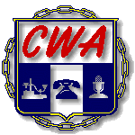
Communications Workers of America

Local 3121, AFL-CIO

RECORD OF INFORMAL GRIEVANCE SETTLEMENT

Grievant Name: Grievance No.

Date of Informal Meeting with Management:

Company Representative in Attendance:

Union Representative in Attendance:

Issue and Article of Contract Involved: Article #

Settlement:

Company Representative Signature Steward Signature

CWA Local 3121
Fax: (305)822-1162 Grievant Signature

